|  |  |  |
| --- | --- | --- |
| **Python**  Lambda: <https://www.python-course.eu/lambda.php>  Pandas each to understand - <https://www.shanelynn.ie/using-pandas-dataframe-creating-editing-viewing-data-in-python/>  Fixed Widths - <http://pyhyd.blogspot.com/2017/06/pandas-how-to-read-text-files-delimited.html>  Gradient Boosting:-  <https://www.analyticsvidhya.com/blog/2016/02/complete-guide-parameter-tuning-gradient-boosting-gbm-python/>  NeuralNetwrok & Deep Learning <http://neuralnetworksanddeeplearning.com/>  **Demographic segmentation model**  **Pyspark-SQLContext**  [**https://www.analyticsvidhya.com/blog/2016/10/spark-dataframe-and-operations/**](https://www.analyticsvidhya.com/blog/2016/10/spark-dataframe-and-operations/)  **Transformation:-**  [**https://spark.apache.org/docs/latest/rdd-programming-guide.html**](https://spark.apache.org/docs/latest/rdd-programming-guide.html)  **Machine Learning Cheat Sheets**  [**https://blog.makcorps.com/2018/08/cheat-sheets-for-ai-neural-networks.html?m=1**](https://blog.makcorps.com/2018/08/cheat-sheets-for-ai-neural-networks.html?m=1)  **Deploy the model into Prod**  [**https://medium.freecodecamp.org/a-beginners-guide-to-training-and-deploying-machine-learning-models-using-python-48a313502e5a**](https://medium.freecodecamp.org/a-beginners-guide-to-training-and-deploying-machine-learning-models-using-python-48a313502e5a)  **Precision/Recall/F1-score**  [**https://blog.exsilio.com/all/accuracy-precision-recall-f1-score-interpretation-of-performance-measures/**](https://blog.exsilio.com/all/accuracy-precision-recall-f1-score-interpretation-of-performance-measures/)  [**https://tryolabs.com/blog/2013/03/25/why-accuracy-alone-bad-measure-classification-tasks-and-what-we-can-do-about-it/**](https://tryolabs.com/blog/2013/03/25/why-accuracy-alone-bad-measure-classification-tasks-and-what-we-can-do-about-it/)  **Model Evaluation:-**  [**https://machinelearningmastery.com/metrics-evaluate-machine-learning-algorithms-python/**](https://machinelearningmastery.com/metrics-evaluate-machine-learning-algorithms-python/)  **i'm totally confused that when to use what , like when to use scaling, when to use feature engineering , when to use feature selection ?**  1). You want to scale your data when any variables mean is much larger or smaller than other variable means.  2). You want to use feature engineering every time if you have the proper data.  3). you want to use feature selection when you have a vast list of independent variables and you want to cut that list down to save time for building a model.  **Interview Question:**  [**https://vitalflux.com/18-microsoft-data-science-interview-questions/**](https://vitalflux.com/18-microsoft-data-science-interview-questions/) | **R** Which of the following is also termed as bootstrap aggregation? **Ans:Bagging**  **NLP:**  <https://www.analyticsvidhya.com/blog/2018/02/the-different-methods-deal-text-data-predictive-python/>  <https://www.kaggle.com/kitakoj18/exploring-wine-descriptions-with-nlp-and-kmeans>  <https://www.dataquest.io/blog/natural-language-processing-with-python/>  <https://medium.com/createdd-notes/introduction-to-natural-language-processing-with-python-294988dbae56>  Test the review using NLP & models  <https://medium.com/tensorist/classifying-yelp-reviews-using-nltk-and-scikit-learn-c58e71e962d9>  [**https://medium.com/createdd-notes/introduction-to-natural-language-processing-with-python-294988dbae56**](https://medium.com/createdd-notes/introduction-to-natural-language-processing-with-python-294988dbae56)  [**https://towardsdatascience.com/multi-class-text-classification-with-scikit-learn-12f1e60e0a9f**](https://towardsdatascience.com/multi-class-text-classification-with-scikit-learn-12f1e60e0a9f)  **multiclass classification example**  [**https://www.codementor.io/agarrahul01/multiclass-classification-using-random-forest-on-scikit-learn-library-hkk4lwawu**](https://www.codementor.io/agarrahul01/multiclass-classification-using-random-forest-on-scikit-learn-library-hkk4lwawu)  **Python vs sas**  [**http://songhuiming.github.io/pages/2016/07/12/python-vs-sas/**](http://songhuiming.github.io/pages/2016/07/12/python-vs-sas/)  **Andrew NG:- Microsoft Azure**  [**https://notebooks.azure.com/goldengrape/libraries/deeplearning-ai**](https://notebooks.azure.com/goldengrape/libraries/deeplearning-ai)  [**https://notebooks.azure.com/goldengrape/libraries/deeplearning-ai/html/COURSE%201%20Neural%20Networks%20and%20Deep%20Learning/Week%203/Planar%20data%20classification%20with%20one%20hidden%20layer/testCases.py**](https://notebooks.azure.com/goldengrape/libraries/deeplearning-ai/html/COURSE%201%20Neural%20Networks%20and%20Deep%20Learning/Week%203/Planar%20data%20classification%20with%20one%20hidden%20layer/testCases.py)  **SAS Text mining**  **<https://documentation.sas.com/?docsetId=casml&docsetTarget=viyaml_intro_toc.htm&docsetVersion=8.1&locale=en>** | |
|  | | |
| Visualization Leaner and polynomial | | |
|  | | library(ggplot2)  #Visualising the Linear Regression Result  Ggplot()+  Geom_point(aes(x=dataset$Level, y=dataset$Salary),  Colour = ‘red’)  Geom_line(aes(x=dataset$Level, y=predict(lin_reg, newdata = dataset)),  Colour = ‘Blue’) +  Ggtitle(‘Truth or Bluff’) +  Xlab(‘Leve’) +  Ylab(‘salary’)  #Visualising the Polynomial Regression Result  Ggplot()+  Geom_point(aes(x=dataset$Level, y=dataset$Salary),  Colour = ‘red’)  Geom_line(aes(x=dataset$Level, y=predict(poly_reg, newdata = dataset)),  Colour = ‘Blue’) +  Ggtitle(‘Truth or Bluff’) +  Xlab(‘Leve’) +  Ylab(‘salary’) |
| **Predict the new input value** | |  |
|  | | Use the predict – function  #predicting a new result with Linear regression  Y_pred=predict(lin_reg, data.frame(Leve = 6.5))  #predicting a new result with polynomial Regression  Y_pred = predict(poly_reg, data.frame(Level = 6.5,  Level2 = 6.6^2,  Level3 = 6.5^3,  Level4 = 6.5^4)) |
| **# Regression Template**  # Importing the libraries  import numpy as np  import matplotlib.pyplot as plt  import pandas as pd  # Importing the dataset  dataset = pd.read_csv('Position_Salaries.csv')  X = dataset.iloc[:, 1:2].values  y = dataset.iloc[:, 2].values  # Splitting the dataset into the Training set and Test set  """from sklearn.cross_validation import train_test_split  X_train, X_test, y_train, y_test = train_test_split(X, y, test_size = 0.2, random_state = 0)"""  # Feature Scaling  """from sklearn.preprocessing import StandardScaler  sc_X = StandardScaler()  X_train = sc_X.fit_transform(X_train)  X_test = sc_X.transform(X_test)  sc_y = StandardScaler()  y_train = sc_y.fit_transform(y_train)"""  # Fitting the Regression Model to the dataset  # Create your regressor here  # Predicting a new result  y_pred = regressor.predict(6.5)  # Visualising the Regression results  plt.scatter(X, y, color = 'red')  plt.plot(X, regressor.predict(X), color = 'blue')  plt.title('Truth or Bluff (Regression Model)')  plt.xlabel('Position level')  plt.ylabel('Salary')  plt.show()  # Visualising the Regression results (for higher resolution and smoother curve)  X_grid = np.arange(min(X), max(X), 0.1)  X_grid = X_grid.reshape((len(X_grid), 1))  plt.scatter(X, y, color = 'red')  plt.plot(X_grid, regressor.predict(X_grid), color = 'blue')  plt.title('Truth or Bluff (Regression Model)')  plt.xlabel('Position level')  plt.ylabel('Salary')  plt.show() | | **# Regression Template**  # Importing the dataset  dataset = read.csv('Position_Salaries.csv')  dataset = dataset[2:3]  # Splitting the dataset into the Training set and Test set  # # install.packages('caTools')  # library(caTools)  # set.seed(123)  # split = sample.split(dataset$Salary, SplitRatio = 2/3)  # training_set = subset(dataset, split == TRUE)  # test_set = subset(dataset, split == FALSE)  # Feature Scaling  # training_set = scale(training_set)  # test_set = scale(test_set)  # Fitting the Regression Model to the dataset  # Create your regressor here  # Predicting a new result  y_pred = predict(regressor, data.frame(Level = 6.5))  # Visualising the Regression Model results  # install.packages('ggplot2')  library(ggplot2)  ggplot() +  geom_point(aes(x = dataset$Level, y = dataset$Salary),  colour = 'red') +  geom_line(aes(x = dataset$Level, y = predict(regressor, newdata = dataset)),  colour = 'blue') +  ggtitle('Truth or Bluff (Regression Model)') +  xlab('Level') +  ylab('Salary')  # Visualising the Regression Model results (for higher resolution and smoother curve)  # install.packages('ggplot2')  library(ggplot2)  x_grid = seq(min(dataset$Level), max(dataset$Level), 0.1)  ggplot() +  geom_point(aes(x = dataset$Level, y = dataset$Salary),  colour = 'red') +  geom_line(aes(x = x_grid, y = predict(regressor, newdata = data.frame(Level = x_grid))),  colour = 'blue') +  ggtitle('Truth or Bluff (Regression Model)') +  xlab('Level') +  ylab('Salary') |
| **SVR - Support vector regression** | |  |
| **SVM reference for explanation and diagram**  [**https://blog.statsbot.co/support-vector-machines-tutorial-c1618e635e93**](https://blog.statsbot.co/support-vector-machines-tutorial-c1618e635e93)  [**https://www.svm-tutorial.com/**](https://www.svm-tutorial.com/) | |  |
| **Unlike LinearRegression function in Python SVR function will not take care the Feature Scaling**  **# Importing the libraries**  import numpy as np  import matplotlib.pyplot as plt  import pandas as pd  **# Importing the dataset**  dataset = pd.read_csv('Position_Salaries.csv')  X = dataset.iloc[:, 1:2].values  y = dataset.iloc[:, 2].values  # Feature Scaling  from sklearn.preprocessing import StandardScaler  sc_X = StandardScaler()  sc_y = StandardScaler()  X = sc_X.fit_transform(X)  y = sc_y.fit_transform(y)  # Fitting SVR to the dataset  from sklearn.svm import SVR  regressor = SVR(kernel = 'rbf')  regressor.fit(X, y)  # Predicting a new result  y_pred = regressor.predict(6.5)  y_pred =sc_y.inverse_transform(regressor.predict(sc_X.transform(np.array([[6.5]]))))  **# Visualising the SVR results**  **plt.scatter(X, y, color = 'red')**  **plt.plot(X, regressor.predict(X), color = 'blue')**  **plt.title('Truth or Bluff (SVR)')**  **plt.xlabel('Position level')**  **plt.ylabel('Salary')**  **plt.show()**  **# Visualising the SVR results (for higher resolution and smoother curve)**  **X_grid = np.arange(min(X), max(X), 0.01) # choice of 0.01 instead of 0.1 step because the data is feature scaled**  **X_grid = X_grid.reshape((len(X_grid), 1))**  **plt.scatter(X, y, color = 'red')**  **plt.plot(X_grid, regressor.predict(X_grid), color = 'blue')**  **plt.title('Truth or Bluff (SVR)')**  **plt.xlabel('Position level')**  **plt.ylabel('Salary')**  **plt.show()** | | SVR package – e1071  Svm function  Svm(formula = y ~.,  Data=inputdataset,  Type= regression/classification )    # SVR  # Importing the dataset  dataset = read.csv('Position_Salaries.csv')  dataset = dataset[2:3]  # Splitting the dataset into the Training set and Test set  # # install.packages('caTools')  # library(caTools)  # set.seed(123)  # split = sample.split(dataset$Salary, SplitRatio = 2/3)  # training_set = subset(dataset, split == TRUE)  # test_set = subset(dataset, split == FALSE)  # Feature Scaling  # training_set = scale(training_set)  # test_set = scale(test_set)  # Fitting SVR to the dataset  # install.packages('e1071')  library(e1071)  regressor = svm(formula = Salary ~ .,  data = dataset,  type = 'eps-regression',  kernel = 'radial')  # Predicting a new result  y_pred = predict(regressor, data.frame(Level = 6.5))  # Visualising the SVR results  # install.packages('ggplot2')  library(ggplot2)  ggplot() +  geom_point(aes(x = dataset$Level, y = dataset$Salary),  colour = 'red') +  geom_line(aes(x = dataset$Level, y = predict(regressor, newdata = dataset)),  colour = 'blue') +  ggtitle('Truth or Bluff (SVR)') +  xlab('Level') +  ylab('Salary')  # Visualising the SVR results (for higher resolution and smoother curve)  # install.packages('ggplot2')  library(ggplot2)  x_grid = seq(min(dataset$Level), max(dataset$Level), 0.1)  ggplot() +  geom_point(aes(x = dataset$Level, y = dataset$Salary),  colour = 'red') +  geom_line(aes(x = x_grid, y = predict(regressor, newdata = data.frame(Level = x_grid))),  colour = 'blue') +  ggtitle('Truth or Bluff (SVR)') +  xlab('Level') +  ylab('Salary') |
| Decision Tree | |  |
| **Library –**  **from sklearn.tree import DecisionTreeRegressor**  **regressor = DecisionTreeRegressor(random_state = 0)**  There are some optimal algorithm run internally to make a split , every time we get the same number of split – we select the randam_split=0 value in Decision Tree Function  # Importing the libraries  import numpy as np  import matplotlib.pyplot as plt  import pandas as pd  # Importing the dataset  dataset = pd.read_csv('Position_Salaries.csv')  X = dataset.iloc[:, 1:2].values  y = dataset.iloc[:, 2].values  # Splitting the dataset into the Training set and Test set  """from sklearn.cross_validation import train_test_split  X_train, X_test, y_train, y_test = train_test_split(X, y, test_size = 0.2, random_state = 0)"""  # Feature Scaling  """from sklearn.preprocessing import StandardScaler  sc_X = StandardScaler()  X_train = sc_X.fit_transform(X_train)  X_test = sc_X.transform(X_test)  sc_y = StandardScaler()  y_train = sc_y.fit_transform(y_train)"""  # Fitting Decision Tree Regression to the dataset  from sklearn.tree import DecisionTreeRegressor  regressor = DecisionTreeRegressor(random_state = 0)  regressor.fit(X, y)  # Predicting a new result  y_pred = regressor.predict(6.5)  # Visualising the Decision Tree Regression results (higher resolution)  X_grid = np.arange(min(X), max(X), 0.01)  X_grid = X_grid.reshape((len(X_grid), 1))  plt.scatter(X, y, color = 'red')  plt.plot(X_grid, regressor.predict(X_grid), color = 'blue')  plt.title('Truth or Bluff (Decision Tree Regression)')  plt.xlabel('Position level')  plt.ylabel('Salary')  plt.show() | | **Library - rpart**  # Decision Tree Regression  # Importing the dataset  dataset = read.csv('Position_Salaries.csv')  dataset = dataset[2:3]  # Splitting the dataset into the Training set and Test set  # # install.packages('caTools')  # library(caTools)  # set.seed(123)  # split = sample.split(dataset$Salary, SplitRatio = 2/3)  # training_set = subset(dataset, split == TRUE)  # test_set = subset(dataset, split == FALSE)  # Feature Scaling  # training_set = scale(training_set)  # test_set = scale(test_set)  # Fitting Decision Tree Regression to the dataset  # install.packages('rpart')  library(rpart)  **regressor = rpart(formula = Salary ~ .,**  **data = dataset,**  **control = rpart.control(minsplit = 1))**  # Predicting a new result with Decision Tree Regression  y_pred = predict(regressor, data.frame(Level = 6.5))  # Visualising the Decision Tree Regression results (higher resolution)  # install.packages('ggplot2')  library(ggplot2)  x_grid = seq(min(dataset$Level), max(dataset$Level), 0.01)  ggplot() +  geom_point(aes(x = dataset$Level, y = dataset$Salary),  colour = 'red') +  geom_line(aes(x = x_grid, y = predict(regressor, newdata = data.frame(Level = x_grid))),  colour = 'blue') +  ggtitle('Truth or Bluff (Decision Tree Regression)') +  xlab('Level') +  ylab('Salary')  # Plotting the tree  plot(regressor)  text(regressor) |
| **Random Forest**  Random Forest is the Version of Ensemble Learning you’ve got other version such as gradient boosting  Ensemble Learning is when you take multiple algorithms or the same algorithm multiple times and you put them together to make something much more powerful than the original  Random forest is non-continues regression model – it will create multiple tree with subset of data from the original dataset and find the average and put all the average together and find the final average to predect the value also when we increate the number of trees it may not actually increase the step(staircase) between the data point , it increase the accuracy of the data by the combination of sub-set average.  Three step: class -> object -> method  First step is to import the right class for the job  Second step is to create an object of this class which will be our random forest regressor itself  Third step is to use the ‘method’ to fit our random forest regress into our dataset | | |
| Library - RandomForestRegressor  From sklearn.ensemble import RandomForestRegressor  Regressor = RandomForestRegression(n_estimator = 10, random_state = 0)  Regressor .fit(x,y)  N_estimator = number of tree need to build  # Random Forest Regression  # Importing the libraries  import numpy as np  import matplotlib.pyplot as plt  import pandas as pd  # Importing the dataset  dataset = pd.read_csv('Position_Salaries.csv')  X = dataset.iloc[:, 1:2].values  y = dataset.iloc[:, 2].values  # Splitting the dataset into the Training set and Test set  """from sklearn.cross_validation import train_test_split  X_train, X_test, y_train, y_test = train_test_split(X, y, test_size = 0.2, random_state = 0)"""  # Feature Scaling  """from sklearn.preprocessing import StandardScaler  sc_X = StandardScaler()  X_train = sc_X.fit_transform(X_train)  X_test = sc_X.transform(X_test)  sc_y = StandardScaler()  y_train = sc_y.fit_transform(y_train)"""  # Fitting Random Forest Regression to the dataset  from sklearn.ensemble import RandomForestRegressor  regressor = RandomForestRegressor(n_estimators = 10, random_state = 0)  regressor.fit(X, y)  # Predicting a new result  y_pred = regressor.predict(6.5)  # Visualising the Random Forest Regression results (higher resolution)  X_grid = np.arange(min(X), max(X), 0.01)  X_grid = X_grid.reshape((len(X_grid), 1))  plt.scatter(X, y, color = 'red')  plt.plot(X_grid, regressor.predict(X_grid), color = 'blue')  plt.title('Truth or Bluff (Random Forest Regression)')  plt.xlabel('Position level')  plt.ylabel('Salary')  plt.show() | | **Library – randomForest**  **Num of tree argument option – ntree=10**  # Random Forest Regression  # Importing the dataset  dataset = read.csv('Position_Salaries.csv')  dataset = dataset[2:3]  # Splitting the dataset into the Training set and Test set  # # install.packages('caTools')  # library(caTools)  # set.seed(123)  # split = sample.split(dataset$Salary, SplitRatio = 2/3)  # training_set = subset(dataset, split == TRUE)  # test_set = subset(dataset, split == FALSE)  # Feature Scaling  # training_set = scale(training_set)  # test_set = scale(test_set)  # Fitting Random Forest Regression to the dataset  # install.packages('randomForest')  library(randomForest)  set.seed(1234)  regressor = randomForest(x = dataset[-2],  y = dataset$Salary,  **ntree = 500**)  # Predicting a new result with Random Forest Regression  y_pred = predict(regressor, data.frame(Level = 6.5))  # Visualising the Random Forest Regression results (higher resolution)  # install.packages('ggplot2')  library(ggplot2)  x_grid = seq(min(dataset$Level), max(dataset$Level), 0.01)  ggplot() +  geom_point(aes(x = dataset$Level, y = dataset$Salary),  colour = 'red') +  geom_line(aes(x = x_grid, y = predict(regressor, newdata = data.frame(Level = x_grid))),  colour = 'blue') +  ggtitle('Truth or Bluff (Random Forest Regression)') +  xlab('Level') +  ylab('Salary') |
|  | |  |
| Classification Model  Image result for true positive true negative chart Image result for true positive true negative chart  CRelated image | | |
| Logistic Regression  Real time stepby step process  <https://towardsdatascience.com/building-a-logistic-regression-in-python-step-by-step-becd4d56c9c8>  <http://blog.yhat.com/posts/logistic-regression-and-python.html>  <https://datascienceplus.com/building-a-logistic-regression-in-python-step-by-step/>  Chisqure and p-value test:-  <https://pythonfordatascience.org/chi-square-python/> | |  |
| K-Nearest neighbors | |  |
| [**http://www.saedsayad.com/k_nearest_neighbors.htm**](http://www.saedsayad.com/k_nearest_neighbors.htm)   |  |  |  | | --- | --- | --- | | **Algorithm** |  |  | | A case is classified by a majority vote of its neighbors, with the case being assigned to the class most common amongst its K nearest neighbors measured by a distance function. If K = 1, then the case is simply assigned to the class of its nearest neighbor. |  |  | |  |  |  | | http://www.saedsayad.com/images/KNN_similarity.png |  |  | |  |  |  | | It should also be noted that all three distance measures are only valid for continuous variables. In the instance of categorical variables the Hamming distance must be used. It also brings up the issue of standardization of the numerical variables between 0 and 1 when there is a mixture of numerical and categorical variables in the dataset. |  |  | | http://www.saedsayad.com/images/KNN_hamming.png |  |  | | | |
| **Naïve Bayes**    **Step1:-**    **P(drives) = Number of drivers/Total observations = 20/30**  **Step2:-**  **P(X) =**  **Draw the circle around the new observation (we consider that all the datapoint inside the cirule have similar feature)**  **Draw the circle –we have to decide whether the circle would be smaller or bigger (Algortham will take care of it)**    **Step3:-**      **Naïve** | | |
| **Decision Tree** Split will happen using the GINI impurity or Information gain algorithms(this is based on entropy) Information gain is used to decide which feature to split on at each step in building the tree. Simplicity is best, so we want to keep our tree small. To do so, at each step we should choose the split that results in the purest daughter nodes. A commonly used measure of purity is called information which is measured in bits, not to be confused with the unit of computer memory. For each node of the tree, the information value "represents the expected amount of information that would be needed to specify whether a new instance should be classified yes or no, given that the example reached that node".[[16]](https://en.wikipedia.org/wiki/Decision_tree_learning#cite_note-Witten_2011_102%E2%80%93103-16)  Consider an example data set with four attributes: *outlook* (sunny, overcast, rainy), *temperature* (hot, mild, cool), *humidity* (high, normal), and *windy* (true, false), with a binary (yes or no) target variable, *play*, and 14 data points. To construct a decision tree on this data, we need to compare the information gain of each of four trees, each split on one of the four features. The split with the highest information gain will be taken as the first split and the process will continue until all children nodes are pure, or until the information gain is 0.  The split using the feature *windy* results in two children nodes, one for a *windy* value of true and one for a *windy* value of false. In this data set, there are six data points with a true *windy* value, three of which have a *play* value of yes and three with a *play* value of no. The eight remaining data points with a *windy* value of false contain two no's and six yes's. The information of the *windy*=true node is calculated using the entropy equation above. Since there is an equal number of yes's and no's in this node, we have  {\displaystyle I_{E}([3,3])=-{\frac {3}{6}}\log _{2}^{}{\frac {3}{6}}-{\frac {3}{6}}\log _{2}^{}{\frac {3}{6}}=-{\frac {1}{2}}\log _{2}^{}{\frac {1}{2}}-{\frac {1}{2}}\log _{2}^{}{\frac {1}{2}}=1}  For the node where *windy*=false there were eight data points, six yes's and two no's. Thus we have  {\displaystyle I_{E}([6,2])=-{\frac {6}{8}}\log _{2}^{}{\frac {6}{8}}-{\frac {2}{8}}\log _{2}^{}{\frac {2}{8}}=-{\frac {3}{4}}\log _{2}^{}{\frac {3}{4}}-{\frac {1}{4}}\log _{2}^{}{\frac {1}{4}}=0.8112781}  To find the information of the split, we take the weighted average of these two numbers based on how many observations fell into which node.  {\displaystyle I_{E}([3,3],[6,2])=I_{E}({\text{windy or not}})={\frac {6}{14}}\cdot 1+{\frac {8}{14}}\cdot 0.8112781=0.8921589}  To find the information gain of the split using *windy*, we must first calculate the information in the data before the split. The original data contained nine yes's and five no's.  {\displaystyle I_{E}([9,5])=-{\frac {9}{14}}\log _{2}^{}{\frac {9}{14}}-{\frac {5}{14}}\log _{2}{\frac {5}{14}}=0.940286}  Now we can calculate the information gain achieved by splitting on the *windy* feature.  {\displaystyle IG({\text{windy}})=I_{E}([9,5])-I_{E}([3,3],[6,2])=0.940286-0.8921589=0.0481271}  To build the tree, the information gain of each possible first split would need to be calculated. The best first split is the one that provides the most information gain. This process is repeated for each impure node until the tree is complete. This example is adapted from the example appearing in Witten et al.[[16]](https://en.wikipedia.org/wiki/Decision_tree_learning#cite_note-Witten_2011_102%E2%80%93103-16) | | |
| **Random Forest – Ensemble Learning – taking many different ML algorithm and run multiple time**  **Daddy of the Decision tree.**  **Random forest classifier is a team of decision trees, will create a number of trees using sub-set of data from training dataset and compose our Random forest and then time to make a prediction then each of the trees of the random forest will each one male a prediction whether or not they think that the user will be defaulter or non-defaulter**  **And then Random forest will look at each of the votes of its tress (outcome from the tree) and then we will count the number of votes for each class that has the**  **Number of votes for defaulter and number of vote for non-defaulter and based on the majority vote , random forest will choose a majority vote (most votes form it trees to make it as its ultimate prediction.**  **Note: We no need to scaling the dataset because Random forest is not based on equlident distances, it is based on condition in independent variables. But in we done the scaling in this example just to get the clear plot as the plot pixel is 0.01.**    Related image   |  |  |  |  |  | | --- | --- | --- | --- | --- | |  |  | **Predicted (Decision)** | | **Ho=Disease**  **Ha= no Disease** | | **Actual**  **(state of the world – reality)** |  | **Retain Ho (0)** | **Reject Ho (1)** | | **Ho True (0)** | **TN (D)** | **FP (C ) – Type-1 error** | | **Ho False (1)** | **FN (A) – Type -2 error** | **TP (B)** |  |  |  |  |  |  | | --- | --- | --- | --- | --- | |  |  | **Actual**  **(state of the world – reality)** | | **Ho – no Disease**  **Ha- disease** | | **Predicted (Decision)** |  | **Ho True (has disease)** | **Ho False (no disease)** | | **Retain Ho - True** | **TP** |  | | **Reject Ho - Flse** |  | **TN** |  |  |  |  |  | | --- | --- | --- | --- | |  |  | **Predicted (Decision)** | | | **Actual**  **(state of the world – reality)** |  | **Reject Ho** | **Retain Ho** | | **Ho True - 0** | **FP** | **TN (D)** | | **Ho False - 1** | **TP** | **FN (A)** |   Type I and II Errors  We have to determine whether we accept or reject the null hypothesis. This could result in four different outcomes.   1. Retained the null hypothesis, and the null hypothesis was correct. (No error) 2. Retained the null hypothesis, but the alternative hypothesis was correct. (Type II error, false negative) – **Ha is True , but they fail to reject Ho** 3. Rejected the null hypothesis, but the null hypothesis was correct. (Type I error, false positive) - **Ho is true , but they reject Ho.** 4. Rejected the null hypothesis, and the alternative hypothesis was correct. (No error)   Related image  **We should not finalize the model only based on Accuracy as it will mislead during some situation that is called Accuracy paradox**  **CAP (Cumulate Accuracy Profile) is not the same of ROC c(Receiver Operating Characteristic)urve**    **ROC**  [**http://navan.name/roc/**](http://navan.name/roc/) | | |
| Feature selection:  Univariate Feature selection  Recursive feature elimination  SelectFromModel | | |
| **Cluster: -**  Elbow method to find the optimal number of clusters.  K-Mean cluster   1. Select the number of cluster (i.e. k=2 or 3 or anything) 2. Select at random K point, the centroids (not necessarily from your dataset) 3. Assign each data point to the closest centroid -> That from K clusters (Distant between the centroid to datapoint) 4. Compute and place the new centroid of each cluser 5. Reassign each data point to the new closest centroid. If any reassignment took place, go to STEP4, otherwise go to FIN (Your model is ready) | | |
| We use Euclidean distance        Recolor the datapoint based on the new centroid distance.    Iterative this process until the is no movement in centroid  After iterative process, finally we got below two clusters      Note: Trap    We selected 3 centroids and formed above cluster at the beginning and selected new centroids which given below cluster so situation is where the selection of the Central is at the very start of the algorithm can potentially dictate the outcome of the algorithm  But that’s not a good thing because the centroids are selected at random – There is an addition or modification to Kmean algorithm that allows your to correctly select the centroid – **Solution is K-Means++ algorithm**  (This K-Mean++ happen in backbround in the tool when we use K-mean lib (algorithm)    How many cluster would be better for dataset?  We use the WCSS      Hierarchical Clustering: -    Agglomerative – start from bottom up approach and building to way up  Divisive – starting from Top and Divide into bottom.      Dendrograms:  Dendrogram is the memory  We will | | |
| **Natural Language Processing: -**  **Step to cleaning the Text for NLP:-**   1. Remove the special character – **sub() function** 2. Convert the string to lower case- **lower() function** 3. Split the string into words – **split() function** 4. Remove the stopwords (i.e. irrelevant English work - the, this ..etc) – **stopwords.works(‘english’)** 5. Stemmeing – convert past/future/presentence to present tense (root of the word) (E.g – will love, loved,loving to love as love work represent the same (hint) positive meaning) - **porterStemmer() object and stem() function**   # Natural Language Processing  # Importing the libraries  import numpy as np  import matplotlib.pyplot as plt  import pandas as pd  # Importing the dataset  dataset = pd.read_csv('Restaurant_Reviews.tsv', delimiter = '\t', quoting = 3)  # Cleaning the texts  import re  import nltk  nltk.download('stopwords')  from nltk.corpus import stopwords  from nltk.stem.porter import PorterStemmer  corpus = []  for i in range(0, 1000):  review = re.sub('[^a-zA-Z]', ' ', dataset['Review'][i]) – re.sub - Keep only a-z & A-Z and replace the other char with space  review = review.lower()  review = review.split()  ps = PorterStemmer()  review = [ps.stem(word) for word in review if not word in set(stopwords.words('english'))]  review = ' '.join(review)  corpus.append(review)  # Creating the Bag of Words model  from sklearn.feature_extraction.text import CountVectorizer  cv = CountVectorizer(max_features = 1500)  X = cv.fit_transform(corpus).toarray()  y = dataset.iloc[:, 1].values  # Splitting the dataset into the Training set and Test set  from sklearn.cross_validation import train_test_split  X_train, X_test, y_train, y_test = train_test_split(X, y, test_size = 0.20, random_state = 0)  # Fitting Naive Bayes to the Training set  from sklearn.naive_bayes import GaussianNB  classifier = GaussianNB()  classifier.fit(X_train, y_train)  # Predicting the Test set results  y_pred = classifier.predict(X_test)  # Making the Confusion Matrix  from sklearn.metrics import confusion_matrix  cm = confusion_matrix(y_test, y_pred) | | |
| Bag of word model:-  Corpus is set of clean review  It is a process to create sparse matrix through the process of tokenization,Tokenization is the process of taking all the different words of the review and creating one column for each word , if the word appear in each review (rows) then set the value = 1 otherwise set the value = 0.  Sentiment Analysis:-  <http://pythonforengineers.com/build-a-sentiment-analysis-app-with-movie-reviews/>  Tweeter:- how to opine the consumer access key and other access key  <https://themepacific.com/how-to-generate-api-key-consumer-token-access-key-for-twitter-oauth/994/> | | |
| Neural Network    Input value = dependent variable  W1-Wn – It is signups (weight) - it will send the signal to Neuron – It will crucial to Neural network , what signal to pass not to pass.when we trainin the neural network we basically adjusting the weight across all the signups and that’s’s where gradient descent and back propagation come into play  Step1:- sum all the weights and input.      Step#2Apply the activation function , then weight know whether to pass the signal or not    4 type of activation function:   1. Threshold activation function 2. Sigmoid activation function 3. Rectifier 4. Hyperbolic Tangent     Hidden Layer – Apply Rectifier function  Output Layer – Apply sigmoid function | | |
| Precision, recall   |  | | --- | | **Standardized equations** | | sensitivity = recall = tp / t = tp / (tp + fn) | | specificity = tn / n = tn / (tn + fp) | | precision = tp / p = tp / (tp + fp) |   Type I and II Errors  We have to determine whether we accept or reject the null hypothesis. This could result in four different outcomes.   1. Retained the null hypothesis, and the null hypothesis was correct. (No error) 2. Retained the null hypothesis, but the alternative hypothesis was correct. (Type II error, false negative) 3. Rejected the null hypothesis, but the null hypothesis was correct. (Type I error, false positive) 4. Rejected the null hypothesis, and the alternative hypothesis was correct. (No error)   What do you mean by power of a statistical test?    a. Probability of rejecting H0 when it is false | | |

Tensorflow – It is an open source software librarar for numerical computation using data flow graphs; open source this by Google

Distributed - run on a cluser or Machine or Multiple cpu/gpu on the same machine

Suite of software

Uses – research and development of new ML algorithms (new neural network model)

Taking models form training to production

Large scale distributed models

Model of mobile and embedded systems

Strengths

Each to use stable python API

Run on large as well small system

Efficient and preformation

Great suppor from google

Additional tool like TensorBoard – for Visualization

TensorFlow serving for deployment

Challenges

Distributed suppor still has a way to go

Libraries still being developed

Writing custom code is not straightforward

* Edges represent the data items that is tenses
* Nodes represent the operation in that tenses.
* Y=A+Bx

Input node are – placeholders (input - A & B)

Variable are parameter – passing parameter for A & B

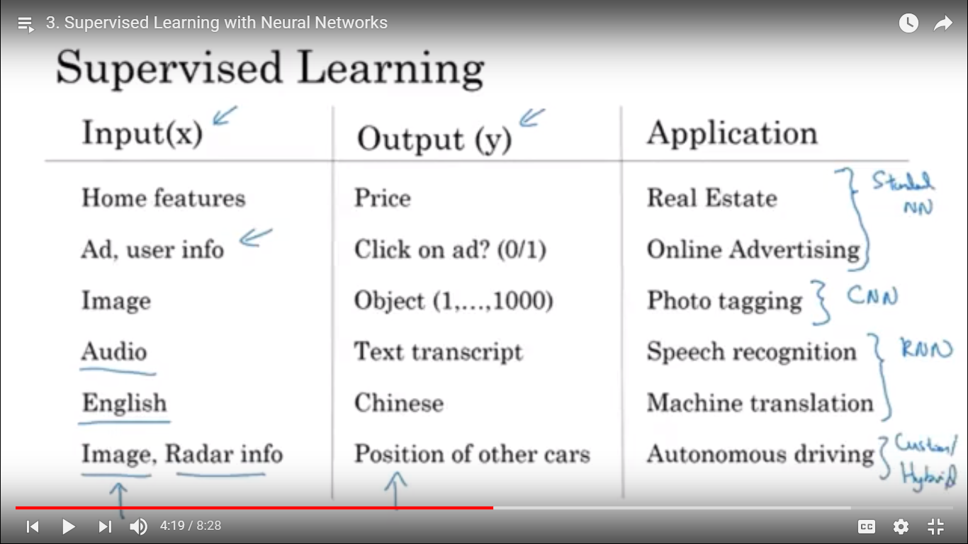

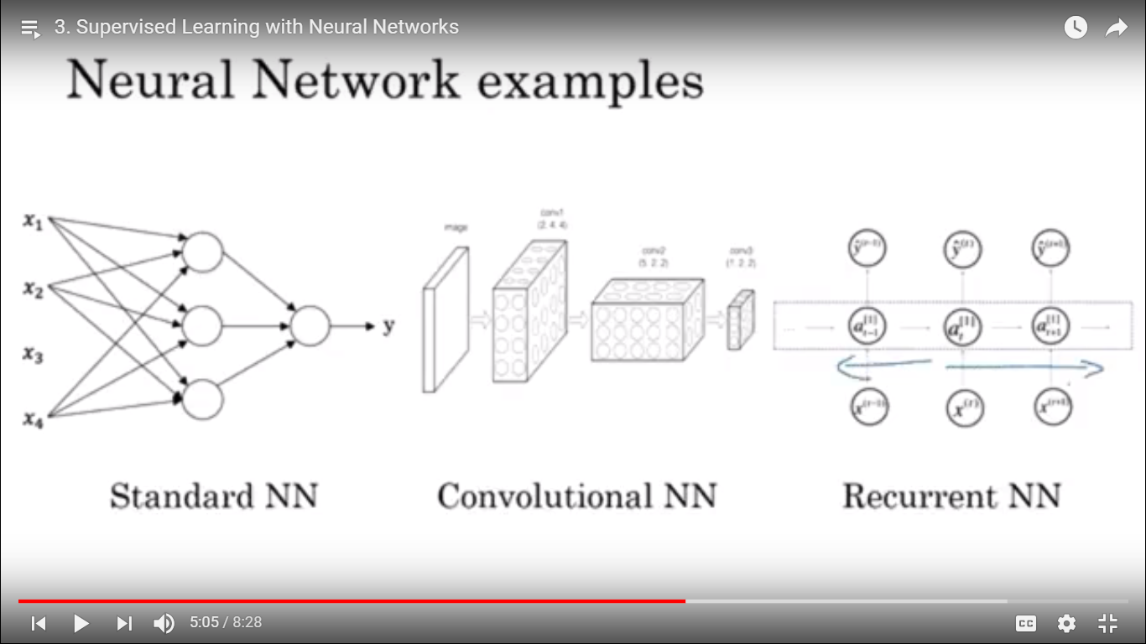

Structured Data – Database data , features(coloumns) has very well defined meaning

Unstructured data – Audio, image, Text – This is complex where you might want to recognize what’s in the image or text here the feature might be pixel value in the image or individual words in the text, historically compute the unstructured data than structured data Deep learning, Neural Netword are now have a capable to work for unstructured data

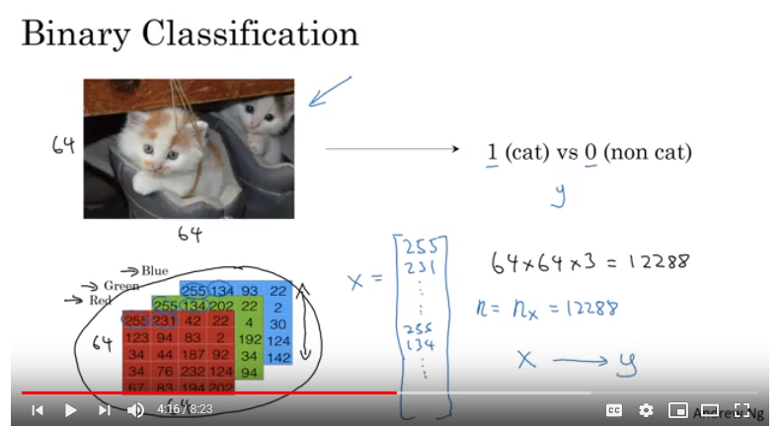

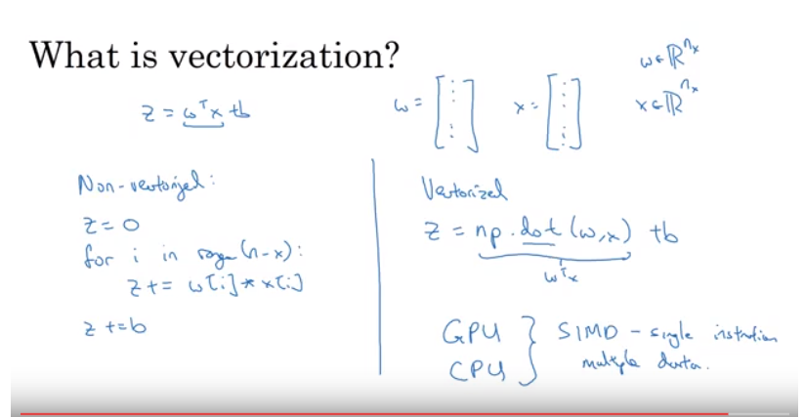

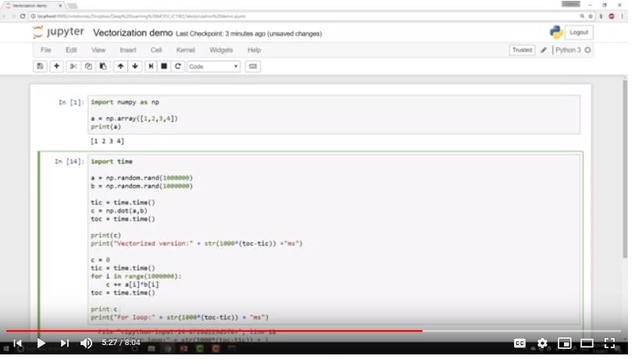

Whenever possible ,Avoid explicit for-loop

Implementing the Logistic regression with gradient computation

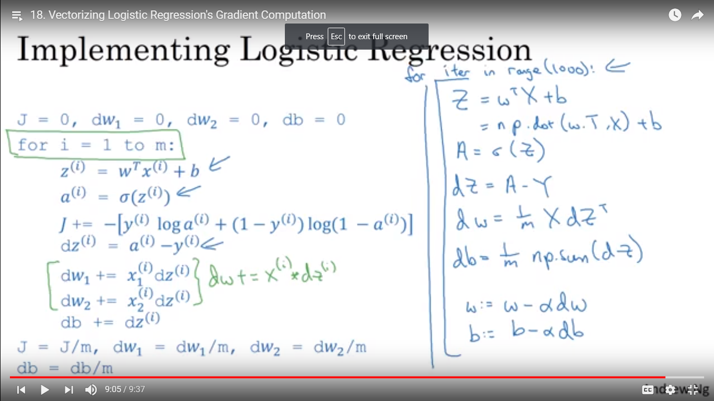

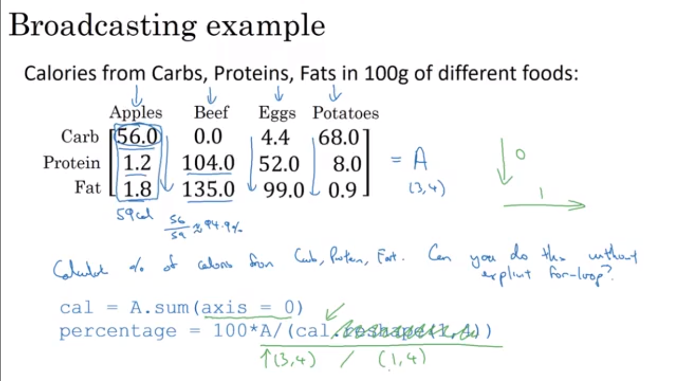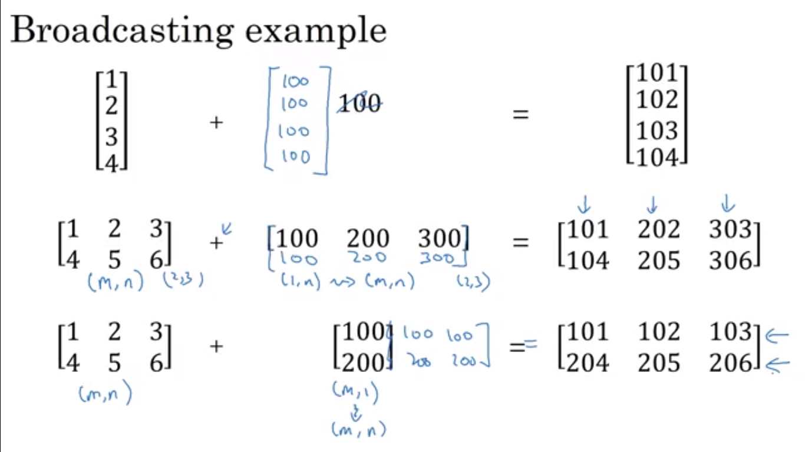

(row, column)

(m,n)

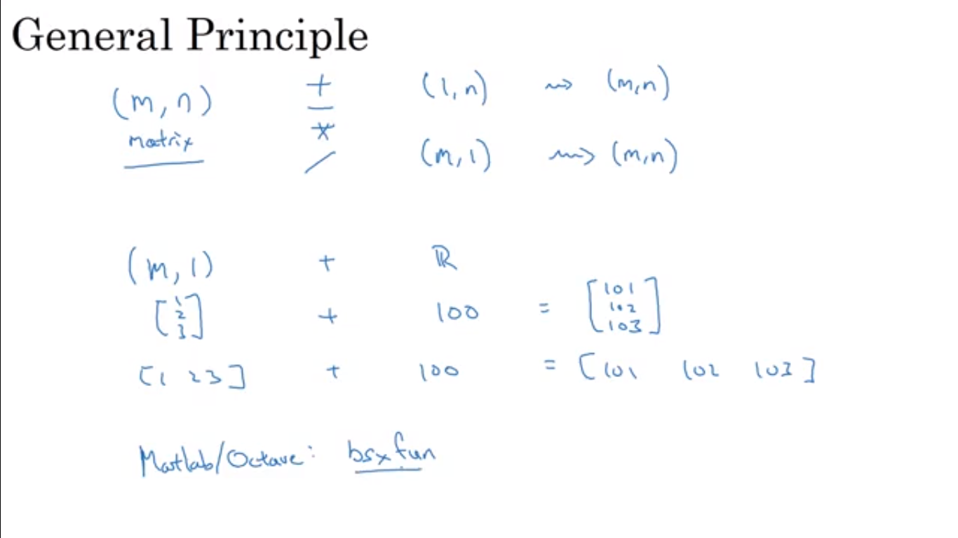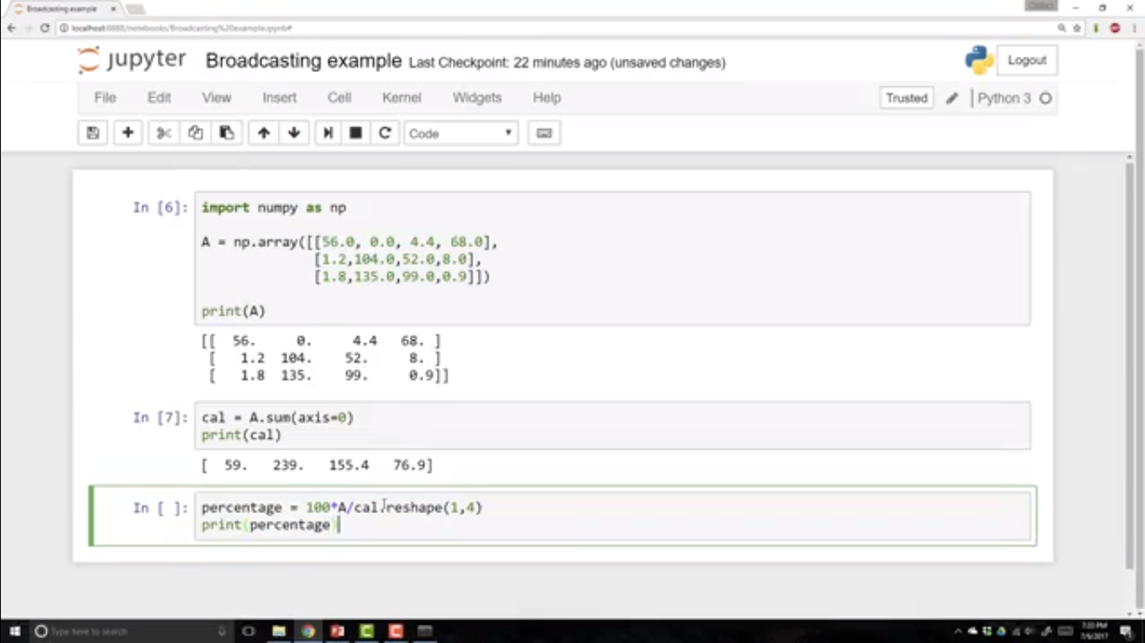

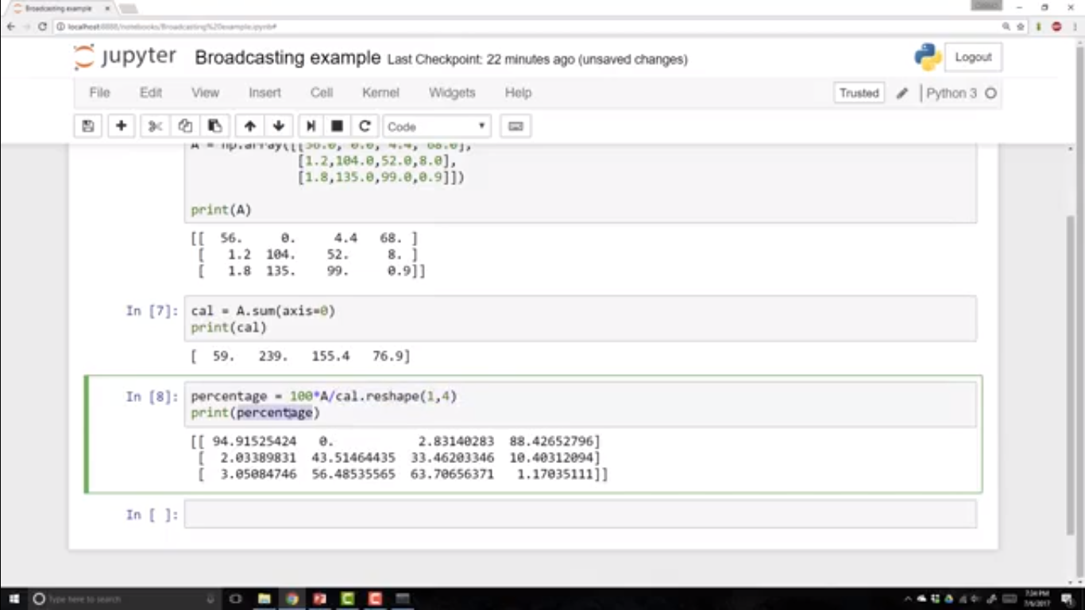

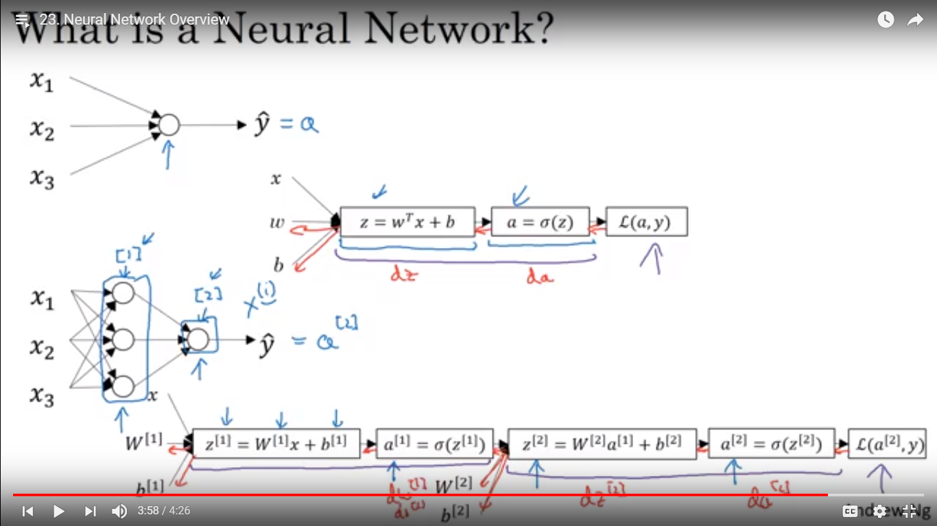

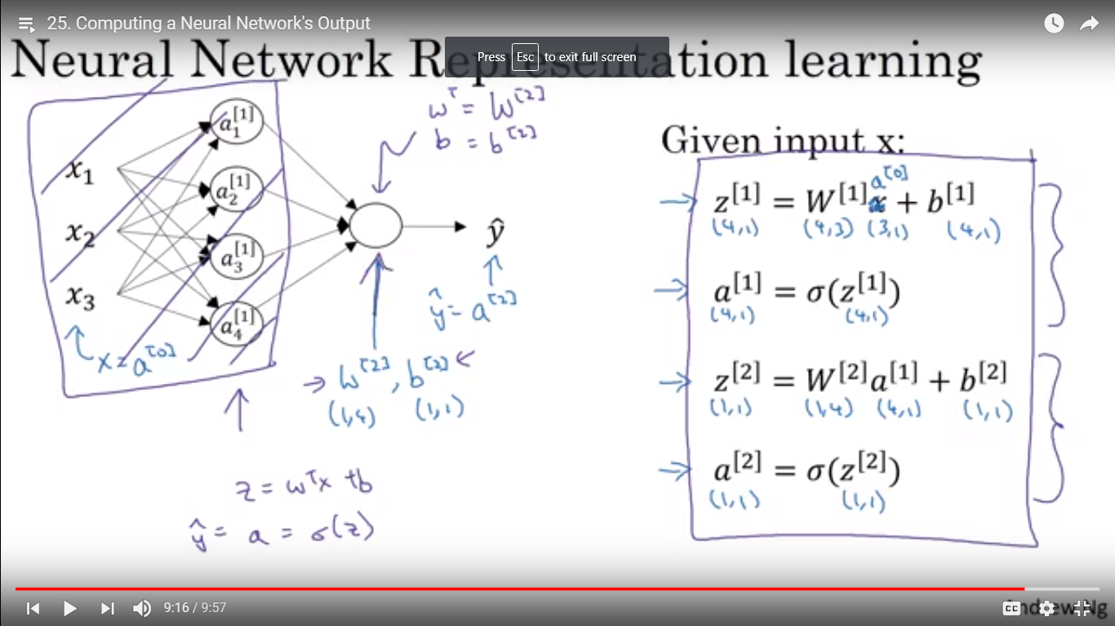

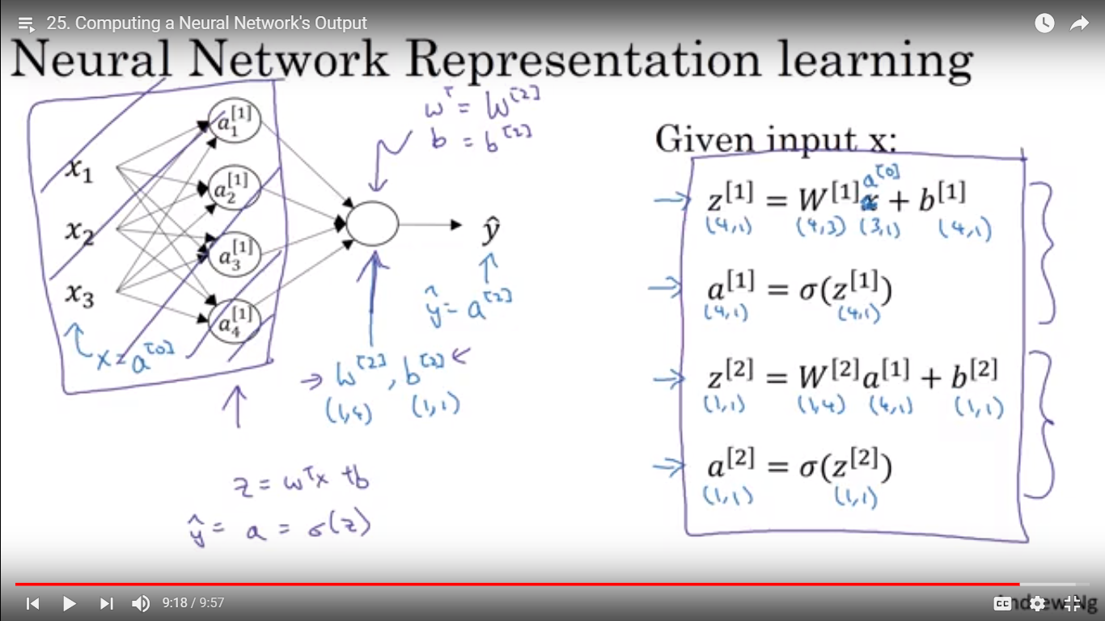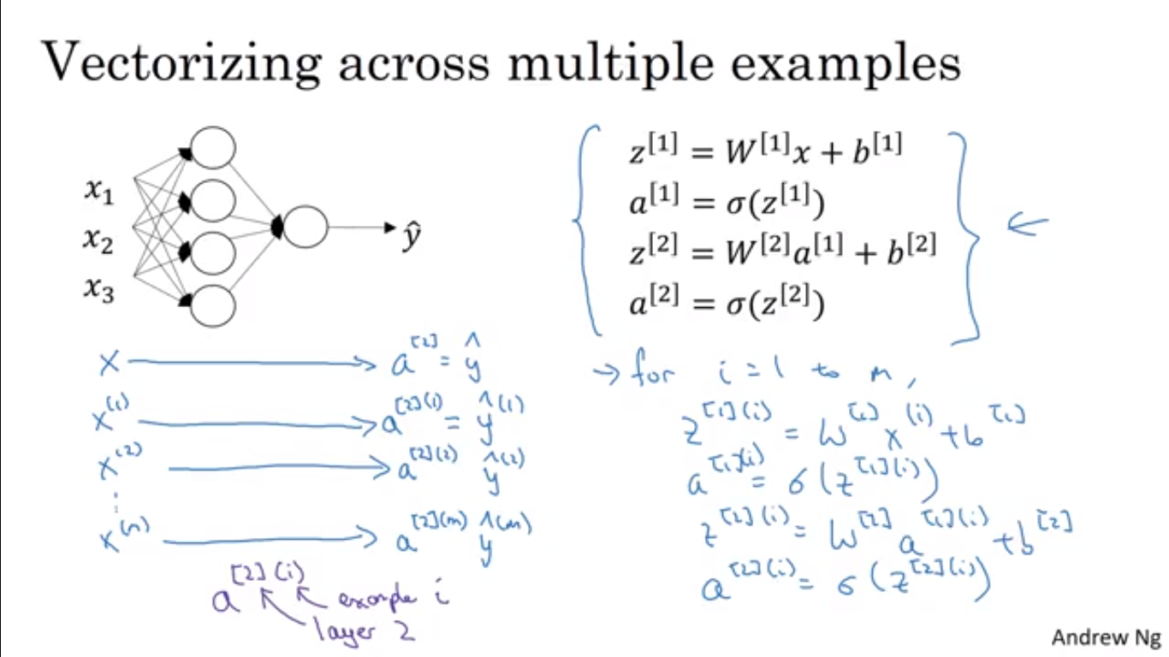

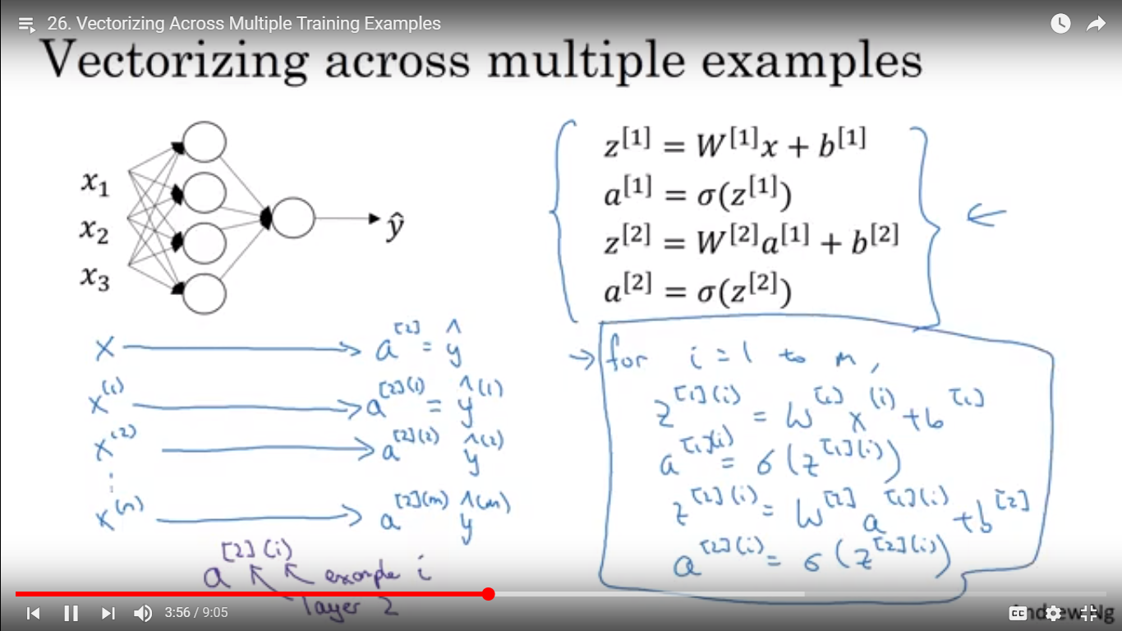

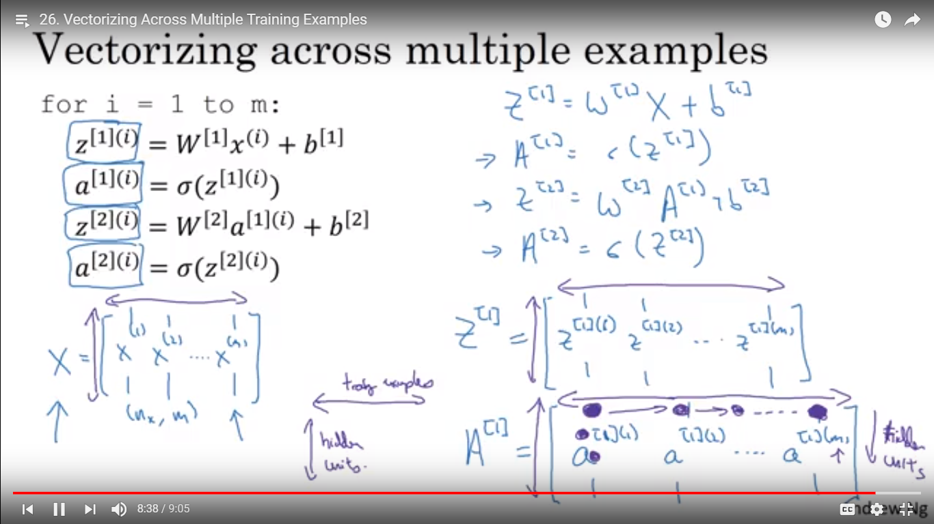

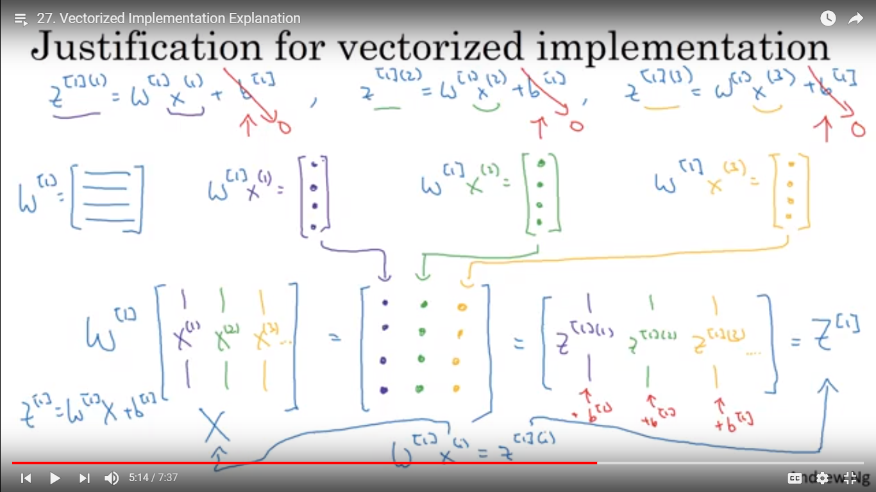

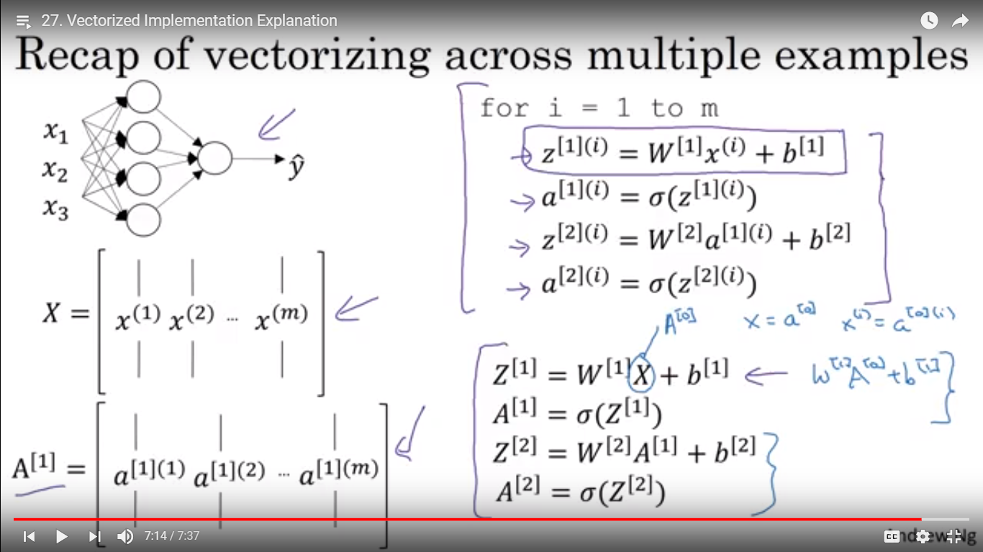

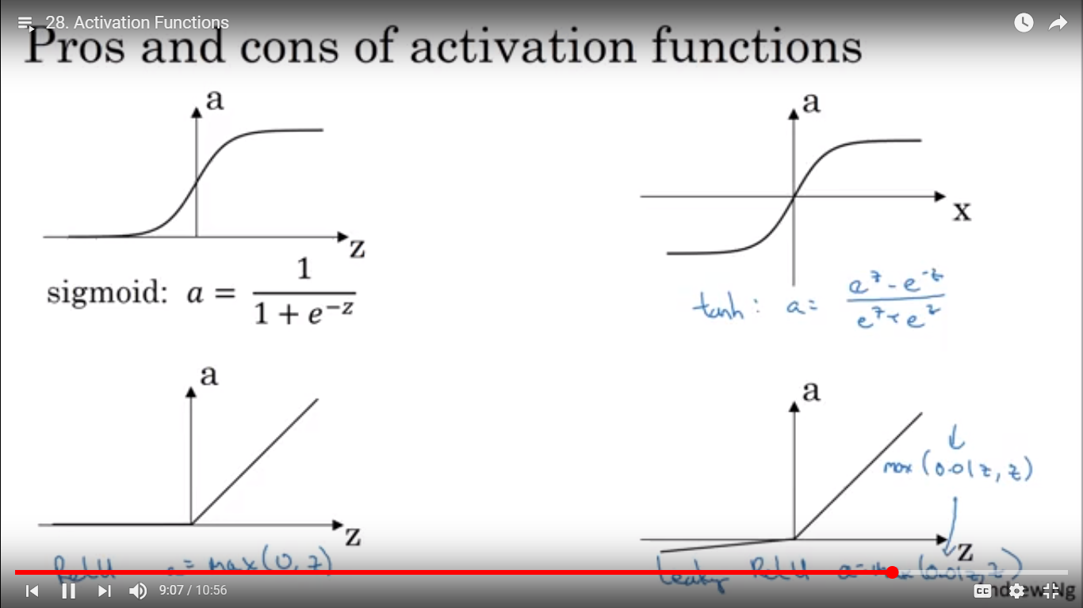

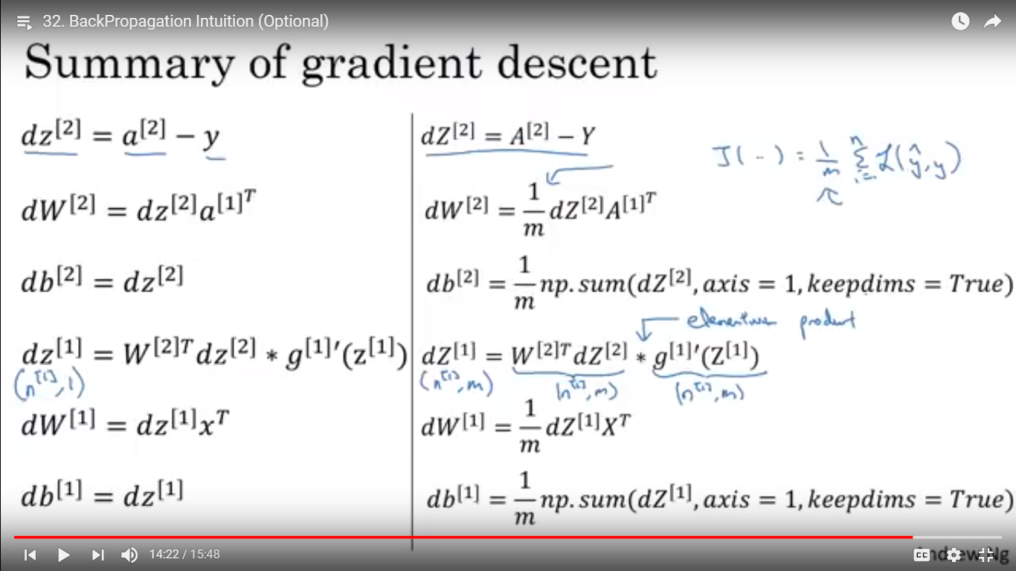

Multi-Layer Notation

